CIS 223 Lab Assignment #1
(Chapter 1)

Create an HTML document in your text editor (Microsoft NotePad for Windows or TextEdit for Mac) and type the <!DOCTYPE> declaration, <html> element, document head, and <body> element. Use the “CIS 223 Lab Assignment #1” as the content of the <title> element (see page 8 for reference)

- Add HTML comments under the <head> tag with your name and homework due date (You may open index.html from the HandsOnProject1-1 folder in the Chapter01 folder of the downloaded Student Data for reference).

- Below the <body> tag, add a line using <h2> element: I am part of the HTML document!.

- Then, enter <script>, insert a blank line and then enter </script> to create a new script section.

- Within the script section you just created, add a JavaScript comment: JavaScript is Fun!

- Then, add a document.write( ) statement, which print Go To JJC Home Page and also link to JJC website.

- Below the </script>, add a pair of <form> and </form> tags.

- Add an <input> element that creates a button. Add onclick attribute that executes an event handler using the JavaScript alert( ) method to display a message: You have done great in this homework! (see page 41, 42, and 68 for reference)

- View your web page in a browser to check the result.

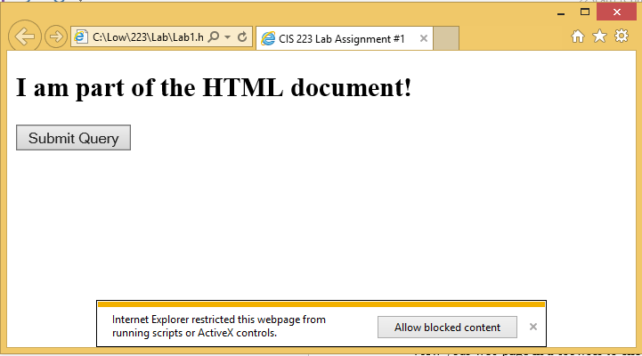

After you click the Allow blocked content button, the Go To JJC Home Page link should appear.

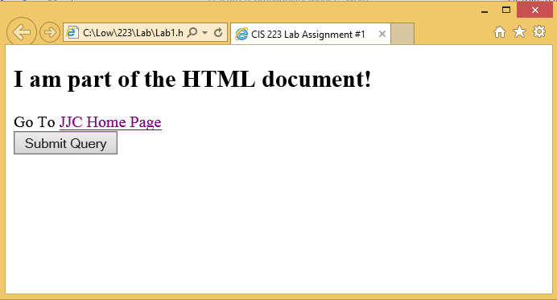

If you click the Submit button, you will see a pop up message dialog:

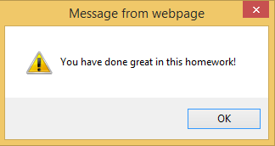

Do not forget to test the JJC Home Page link in your homework.

- Submit your homework (.html document) in iCampus.

